

VLSI DESIGN PROJECTS/INTERNSHIP

# College Name

* **SRM Institute of Science and Technology.**

# Company Name

* **Vyorius.**

# Domain

* **VLSI design.**

### Project topics

### Basic circuits written in Verilog/VHDL, simulated and implemented on the FPGA

### UART communication to print a single character

### FSM Designs: Mealy & Moore Machines and Up Down Counter

**Hardware and software used**

**Hardware,**

# Mimas A7 Mini FPGA Development Board

Mimas A7 Mini is an easy-to-use FPGA Development board featuring Artix 7 FPGA (XC7A35T – FTG256C package) with FTDI’s FT2232H Dual-Channel USB device. It is an Artix-7 based replacement and upgrades of Mimas Spartan 6 FPGA Board. It is specially designed for the development and integration of FPGA based accelerated features to other designs. The USB 2.0 host interface based on popular FT2232H offers high bandwidth data transfer and board programming without the need for any external programming adapters.

**Features,**

* Device: Xilinx Artix 7 FPGA (XC7A35T-1FTG256C)
* DDR3: 2Gb DDR3 (MT41J128M16JT-125 or equivalent)
* Built-in programming interface. No expensive JTAG adapters needed for programming the board
* Onboard 128Mb flash memory for FPGA configuration storage and custom user data storage
* High-Speed USB 2.0 interface for On-board flash programming. FT2232H Channel B is dedicated to JTAG Programming. Channel A can be used for custom applications
* 100MHz CMOS oscillator
* 8 LEDs, 1 RGB LED and 4 Push Buttons for user-defined purposes
* FPGA configuration via JTAG and USB
* Maximum IOs for user-defined purposes

FPGA – 70 IOs (35 professionally length matched Differential Pairs) and two 2×6 Expansion Headers

**Applications,**

* Product Prototype Development
* Accelerated computing integration
* Development and testing of custom embedded processors
* Communication devices development
* Educational tool for Schools and Universities

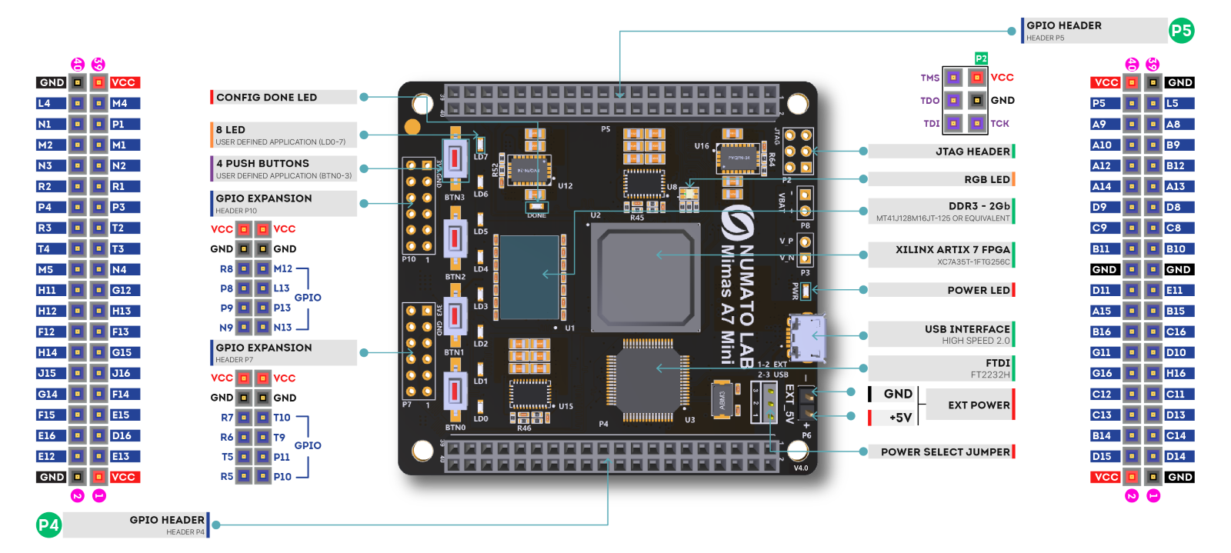

#### **Specifications,**

|  |  |
| --- | --- |
| Attribute | Value |
| **Dimensions** | 6 × 4 × 1 in |
| **FPGA** | [**XC7A35T – 1FTG256C**](https://numato.com/fpga/xc7a35t-1ftg256c/) |
| **Memory** | [**DDR3 – 2Gb**](https://numato.com/memory/ddr3-2gb/) |
| **Configuration Options** | [**JTAG**](https://numato.com/configuration-options/jtag/), [**USB**](https://numato.com/configuration-options/usb/) |
| **Host Interface** | [**USB 2.0**](https://numato.com/host-interface/usb-2-0/) |
| **Primary Clock Frequency** | [**100MHz**](https://numato.com/primary-clock-frequency/100mhz/) |
| **Number Of GPIOs (Max)** | [**70**](https://numato.com/number-of-gpios/70/) |
| **Number Of Diff Pairs** | [**35**](https://numato.com/number-of-diff-pairs/35/) |

**Software**



*Icarus Verilog* is a Verilog simulation and synthesis tool. It operates as a compiler, compiling source code written in Verilog (IEEE-1364) into some target format. For batch simulation, the compiler can generate an intermediate form called *vvp assembly*. This intermediate form is executed by the ``vvp'' command. For synthesis, the compiler generates netlists in the desired format.

The compiler proper is intended to parse and elaborate design descriptions written to the IEEE standard *IEEE Std 1364-2005.* This is a fairly large and complex standard, so it will take some time to fill all the dark alleys of the standard, but that's the goal.

*Icarus Verilog* is a work in progress, and since the language standard is not standing still either, it probably always will be. That is as it should be. However, I will make stable releases from time to time, and will endeavour to not retract any features that appear in these stable releases. The quick links above will show the current stable release.

The main porting target is Linux, although it works well on many similar operating systems. Various people have contributed precompiled binaries of stable releases for a variety of targets. These releases are ported by volunteers, so what binaries are available depends on who takes the time to do the packaging. *Icarus Verilog* has been ported to That Other Operating System, as a command line tool, and there are installers for users without compilers. You can compile it entirely with free tools, too, although there are precompiled binaries of stable releases.



**Vivado Design Suite** is a software suite produced by [Xilinx](https://en.wikipedia.org/wiki/Xilinx) for synthesis and analysis of [HDL](https://en.wikipedia.org/wiki/Hardware_description_language) designs, superseding [Xilinx ISE](https://en.wikipedia.org/wiki/Xilinx_ISE) with additional features for [system on a chip](https://en.wikipedia.org/wiki/System_on_a_chip) development and [high-level synthesis](https://en.wikipedia.org/wiki/High-level_synthesis).[[1]](https://en.wikipedia.org/wiki/Xilinx_Vivado#cite_note-Xilinx-Inc-Apr-2012-8-K-1)[[5]](https://en.wikipedia.org/wiki/Xilinx_Vivado#cite_note-5)[[6]](https://en.wikipedia.org/wiki/Xilinx_Vivado#cite_note-hls1-6)[[7]](https://en.wikipedia.org/wiki/Xilinx_Vivado#cite_note-7) Vivado represents a ground-up rewrite and re-thinking of the entire design flow (compared to ISE).[[8]](https://en.wikipedia.org/wiki/Xilinx_Vivado#cite_note-8)[[9]](https://en.wikipedia.org/wiki/Xilinx_Vivado#cite_note-9)[[10]](https://en.wikipedia.org/wiki/Xilinx_Vivado#cite_note-10)

Like the later versions of [ISE](https://en.wikipedia.org/wiki/Xilinx_ISE), Vivado includes the in-built logic simulator [ISIM](https://www.xilinx.com/products/design-tools/isim.html).[[11]](https://en.wikipedia.org/wiki/Xilinx_Vivado#cite_note-11) Vivado also introduces high-level synthesis, with a toolchain that converts C code into programmable logic.[[6]](https://en.wikipedia.org/wiki/Xilinx_Vivado#cite_note-hls1-6)

Replacing the 15-year-old ISE with Vivado Design Suite took 1000 [person-years](https://en.wikipedia.org/wiki/Person-years) and cost US$200 million.



Tenagra is an FPGA System management tool for configuring and communicating with Numato Lab’s supported FPGA modules and development platforms. This software is designed to be a single interface for managing the devices and exercising some of the available features. Currently, Tenagra supports configuring the FPGA module/board (programming) and Memory Exerciser that can transfer data between various memories on the device. This includes both external DDR Memory and Block RAM available within the FPGA device. With Tenagra, you can create multiple configuration setups with different bitstreams and settings for each device model so that switching between multiple bitstreams is a breeze. This is especially helpful during development where the device may need to be reprogrammed with various bitstreams repeatedly.

**Driver for Mimas A7 Mini Module**



PuTTY is a free implementation of SSH **(and telnet) for PCs running Microsoft Windows** (it also includes an xterm terminal emulator). You will find PuTTY useful if you want to access an account on a Unix or other multi-user system from a PC (for example your own or one in an internet cafe).

3. FSM Designs: Mealy & Moore Machines and Up Down Counter

Step 1- Connect the real time FPGA Mimas A7 mini board, open the device manager to set its configuration. Now we have to get tenegra a software which acts like a bridge between the FPGA board and the pc, where the program will be uploaded. You can get tenegra under Numato Lab

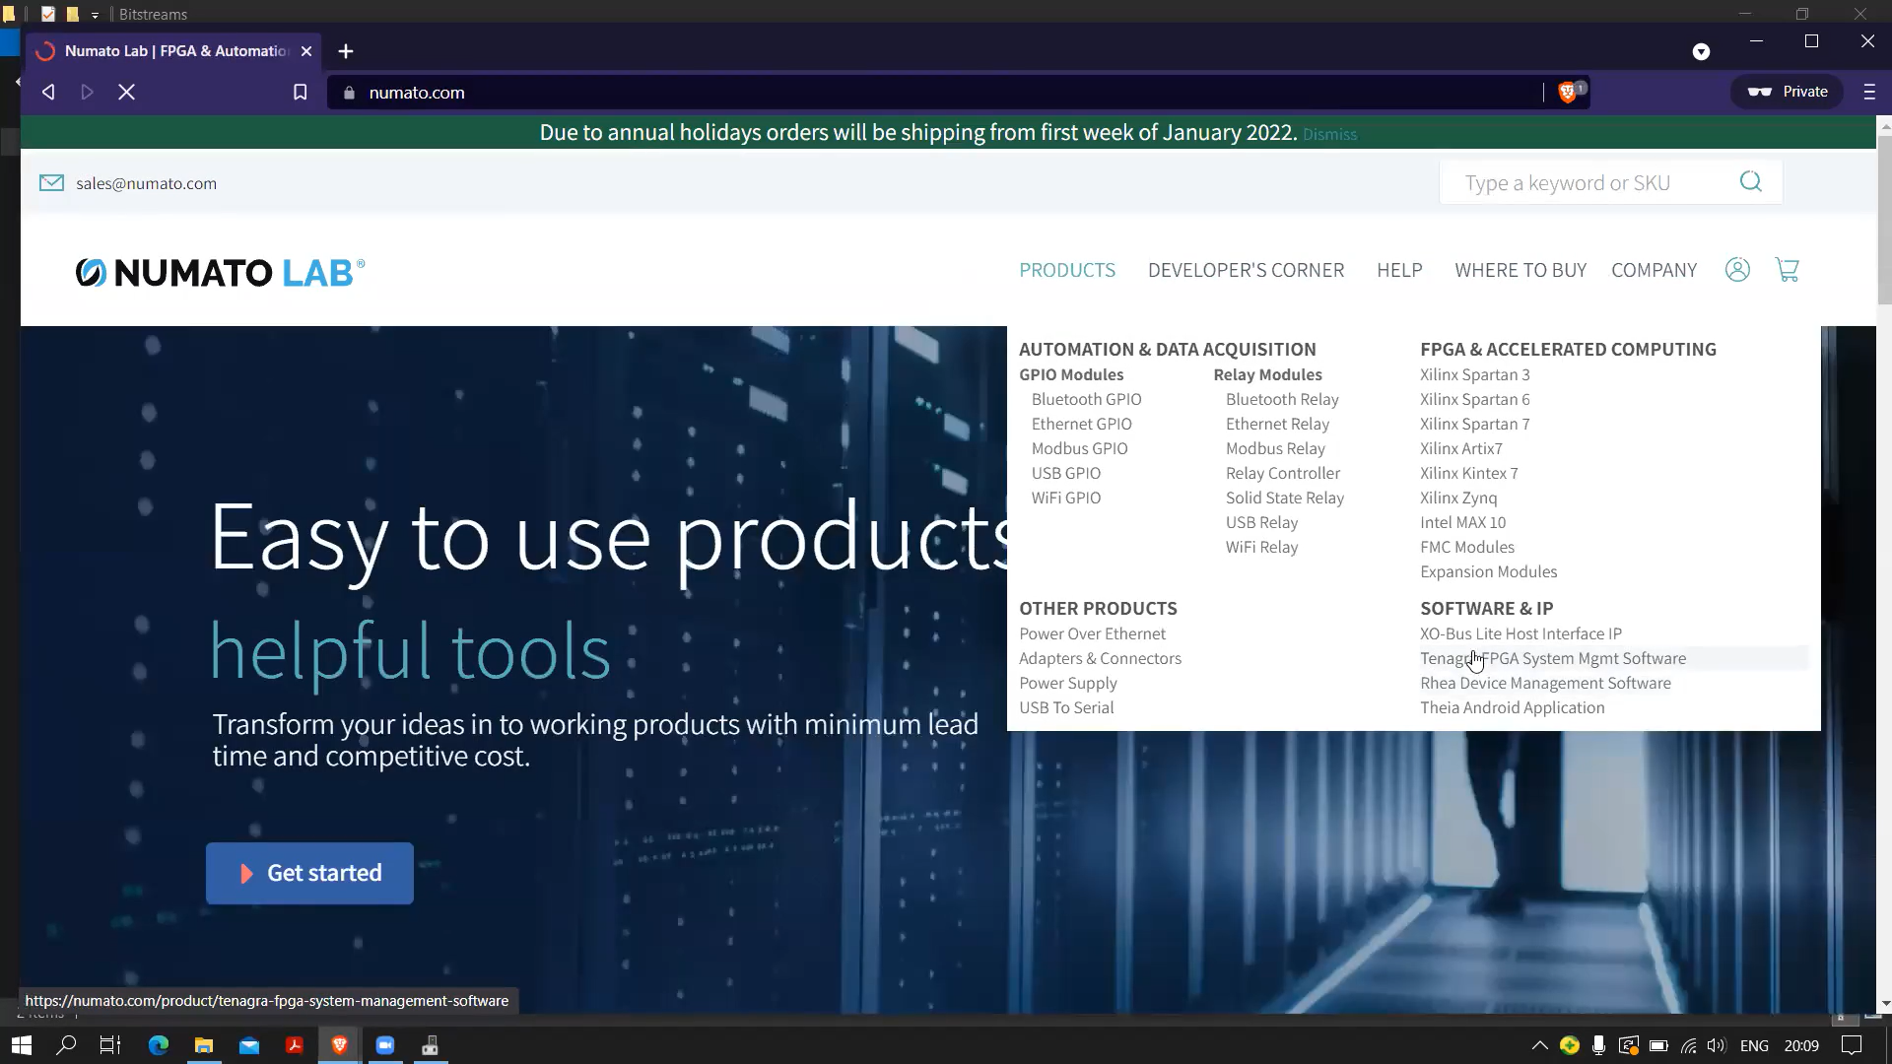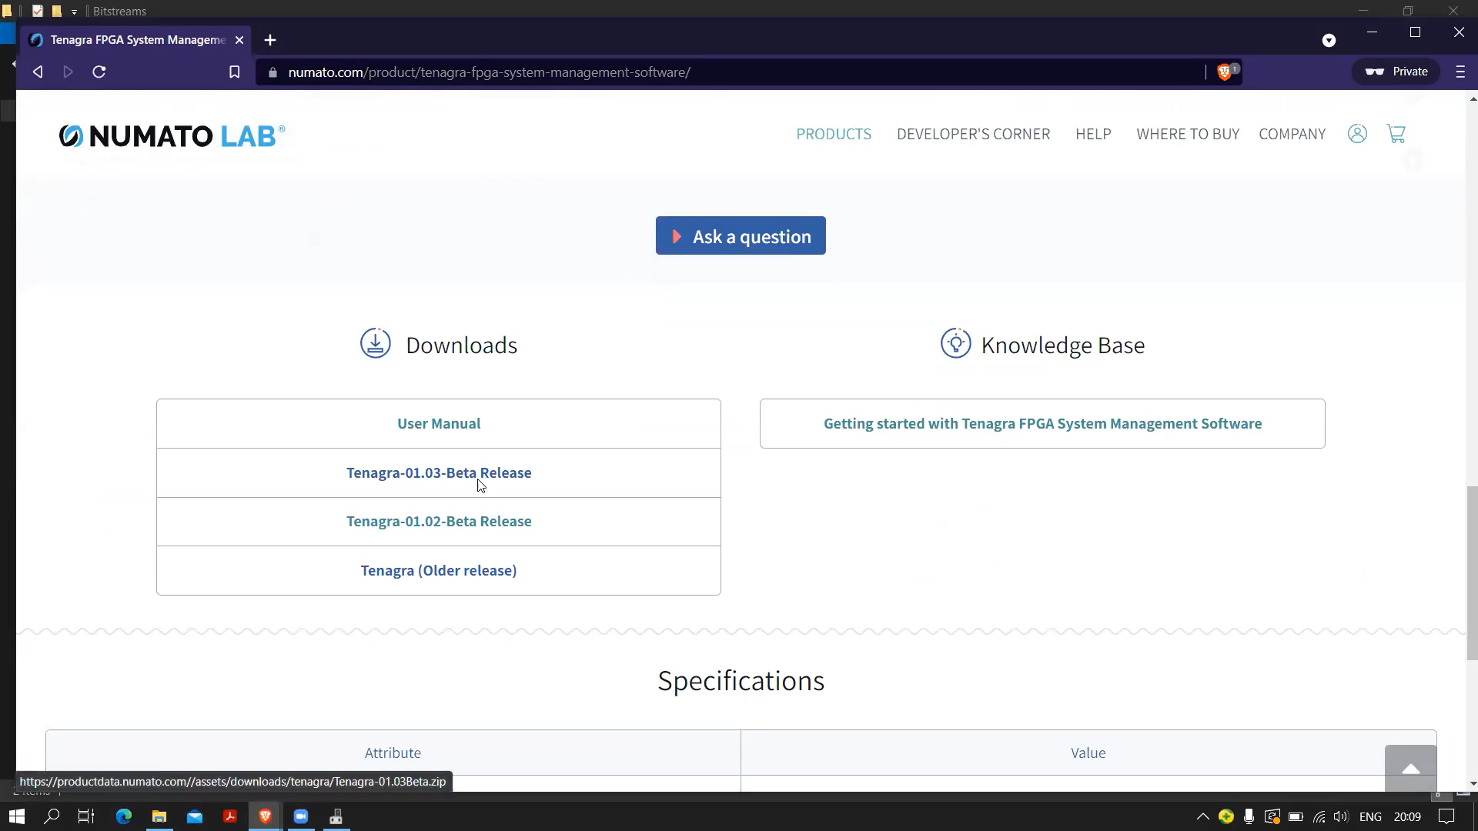After this we have to download few drivers' fir Mimas A7 Mini Module.

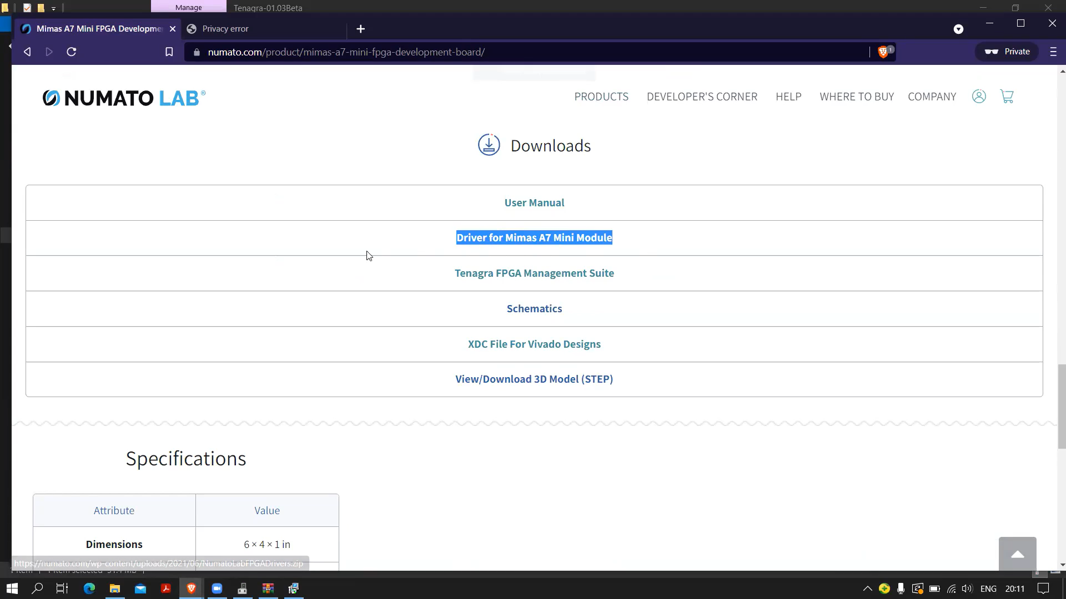Launch tenegra where we will be viewing two ways or methods to put the program in our FPGA .

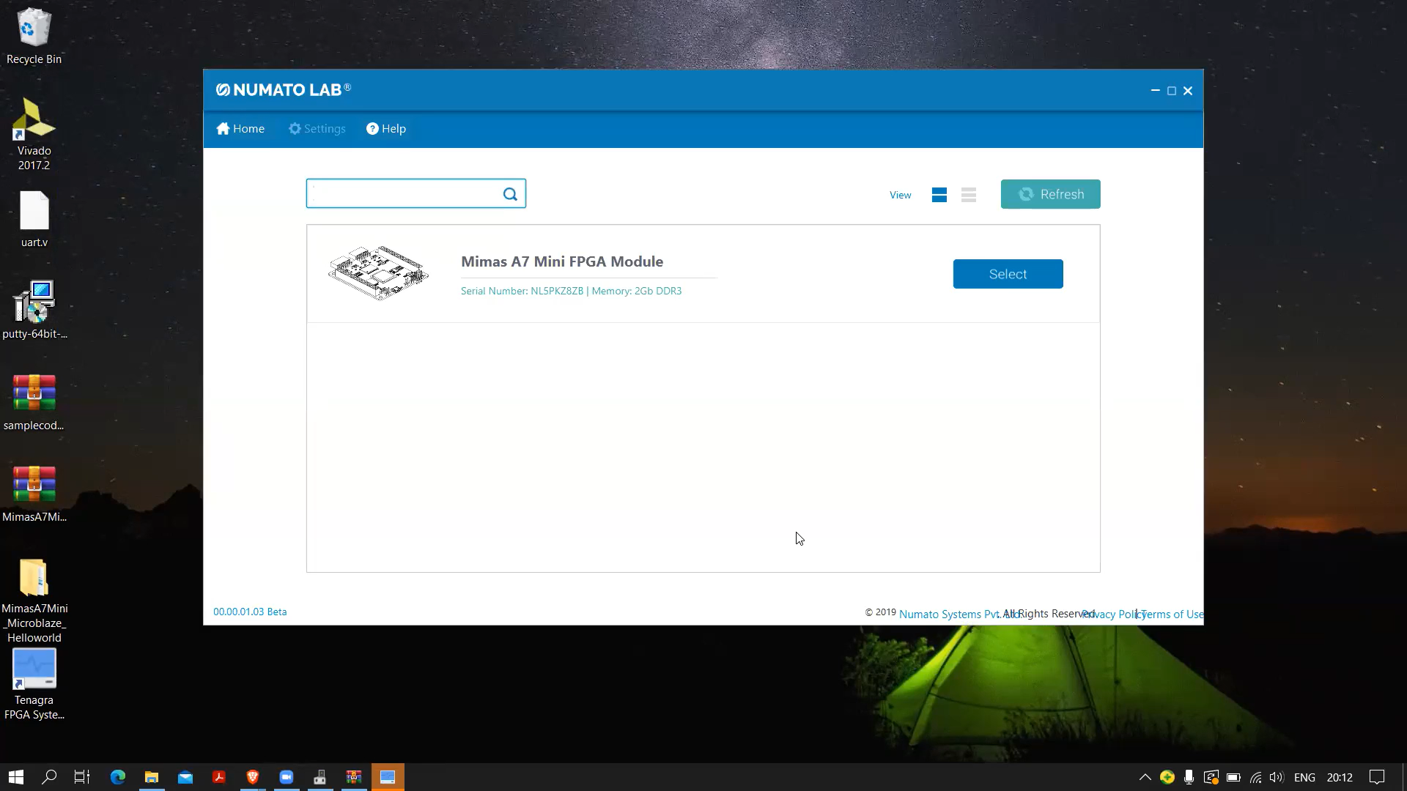We could have used Xilinx jtag , a Xilinx platform cable, as it is quite expensive, we will not be using it rather we will using either of the two ways, XVC Server or Program device.

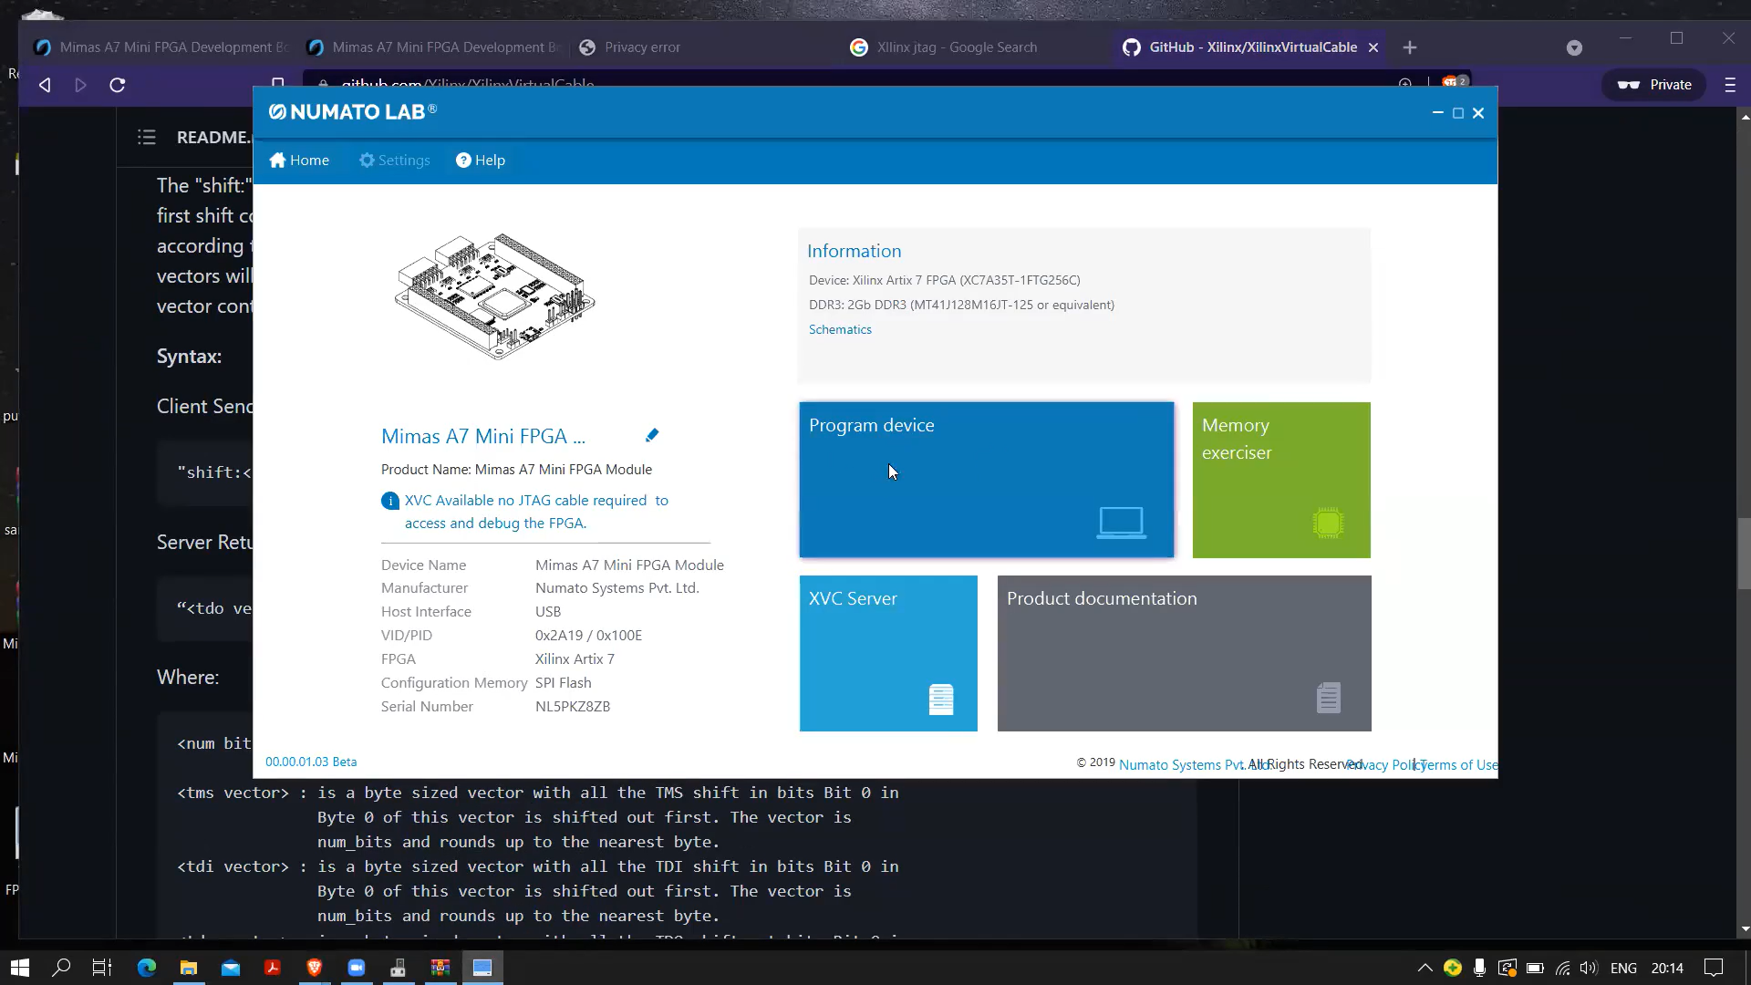

XVC server is nothing but Xilinx virtual cable, you can research and find out what it is. So, this is one way another way which we will be using to program is by an integrated circuit, FT2232HQ an onboard chip already available on Mimas A7 Mini, used for usb communication usb 2.0 communication not usb 3.0 with a speed of 480Mb/s. So, if we conclude we are using normal option that is program device to install the program on the FPGA.

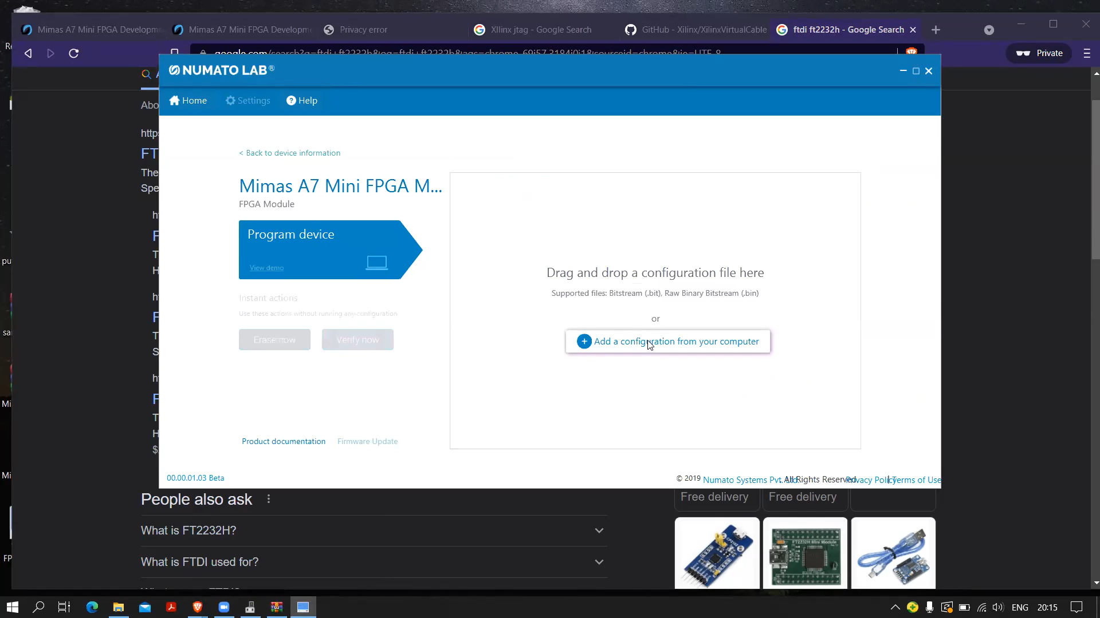Add the bit file saved from Xilinx vivado integrated with this FPGA.

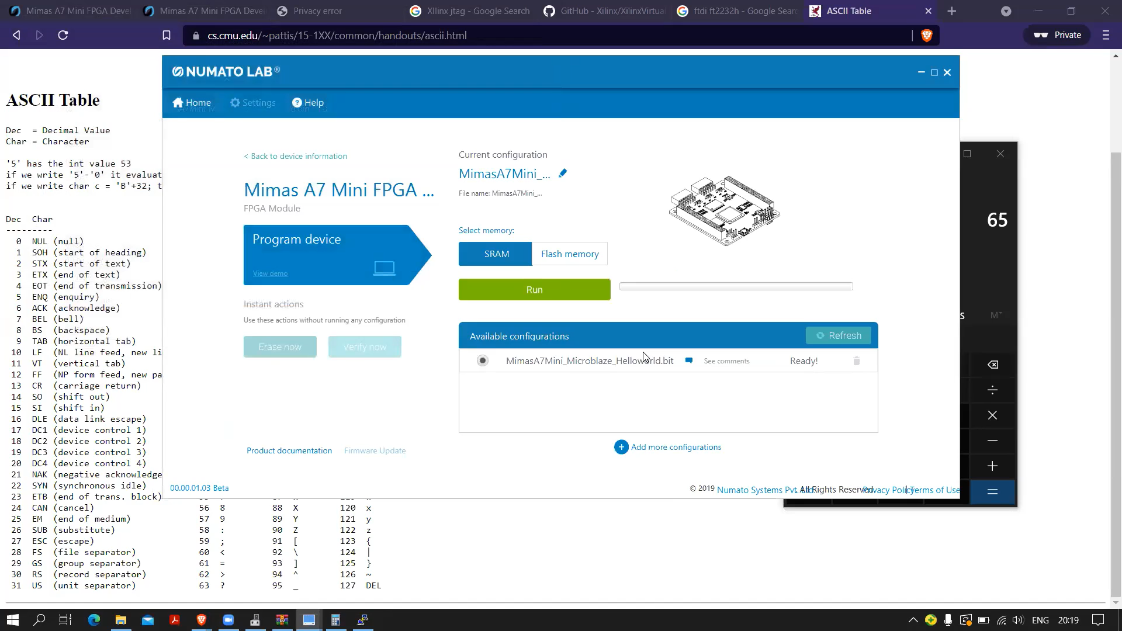Run and configure the board with the program and after that if we have to launch putty software.

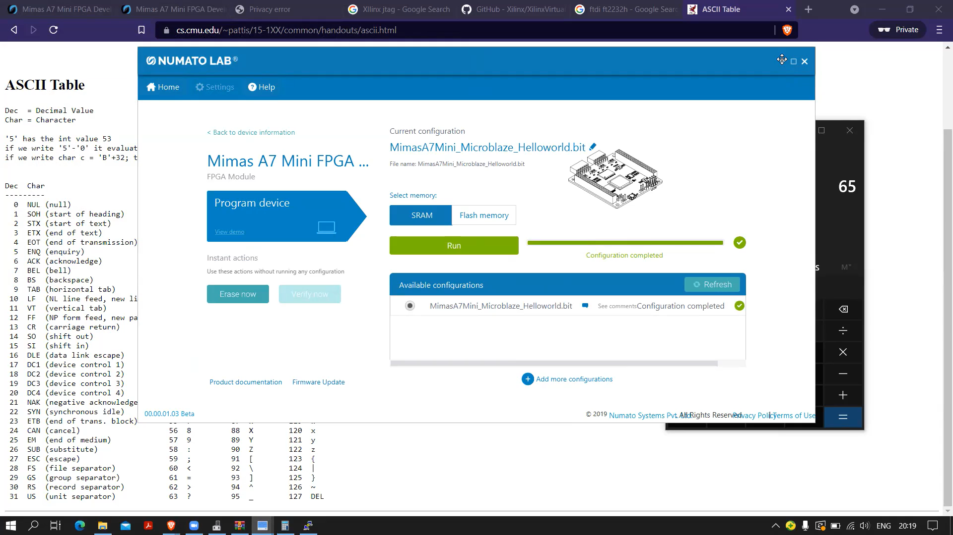

Step 2- Launch putty our serial monitors where it will receive data and make necessary changes with respect to port and connection type and so on.

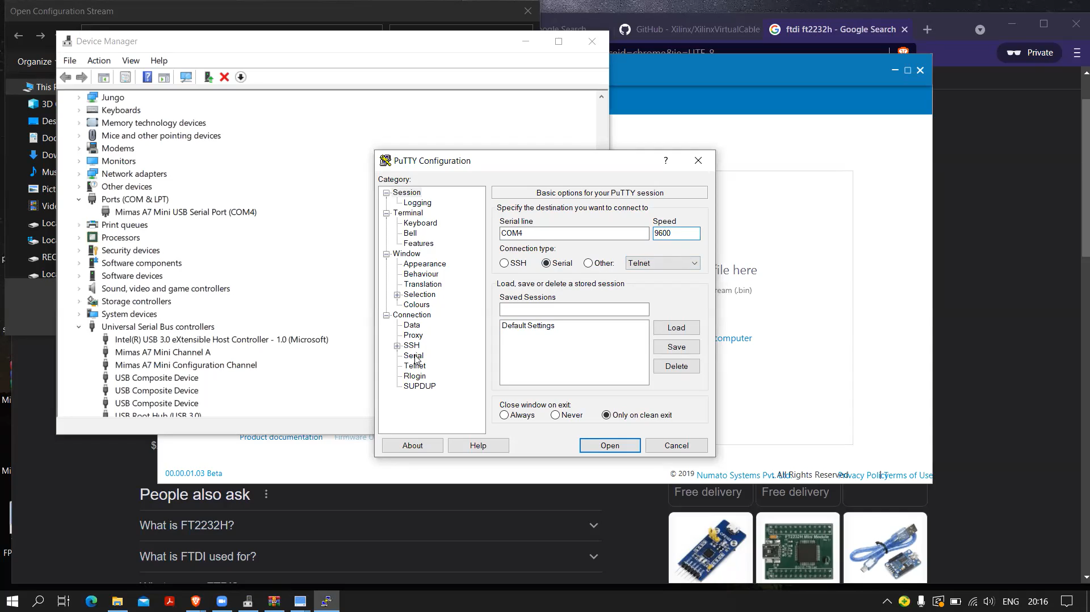

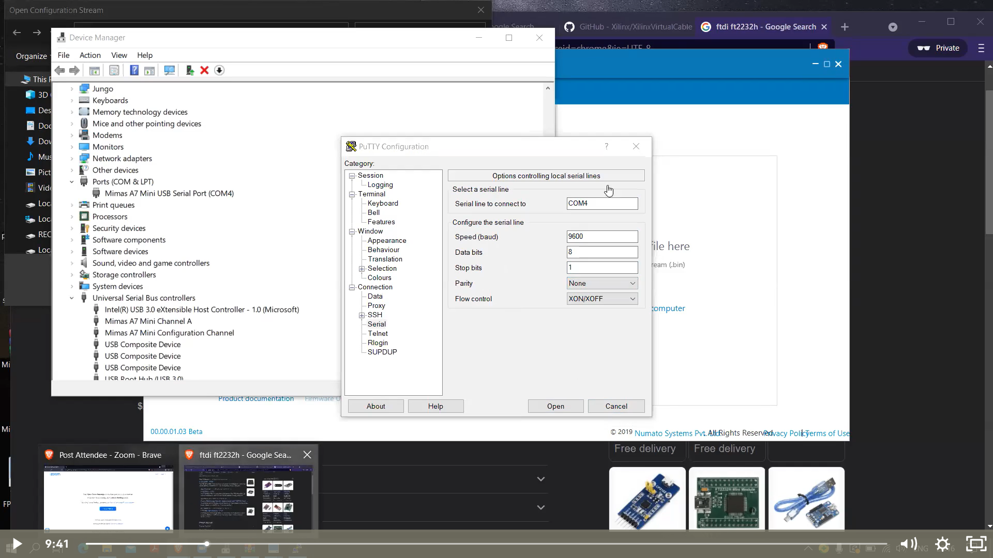

Putty session will continuously print Hello world after we upload the program to our FPGA and even, we can stop it from happening with a reset button present on the board.

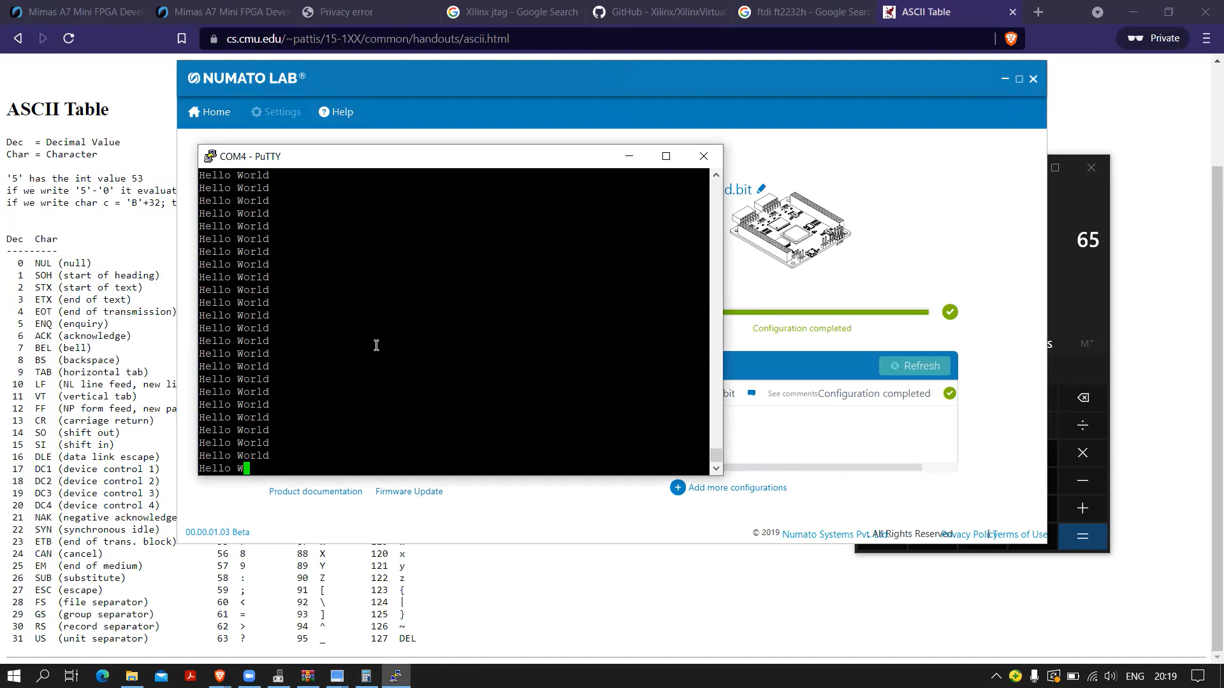

Open the C file where the program for hello world is written.

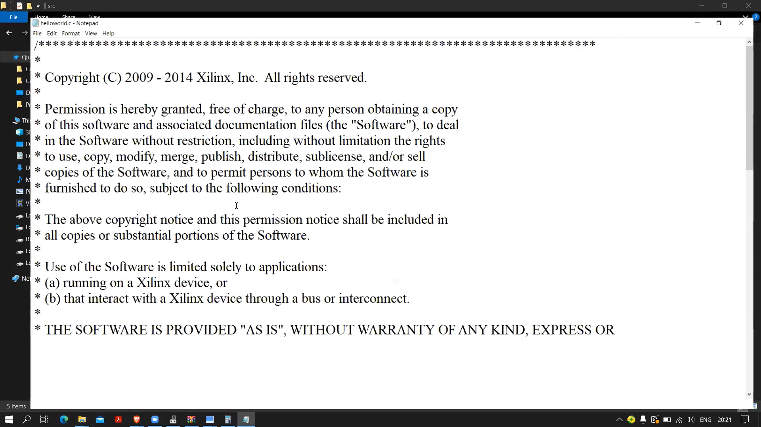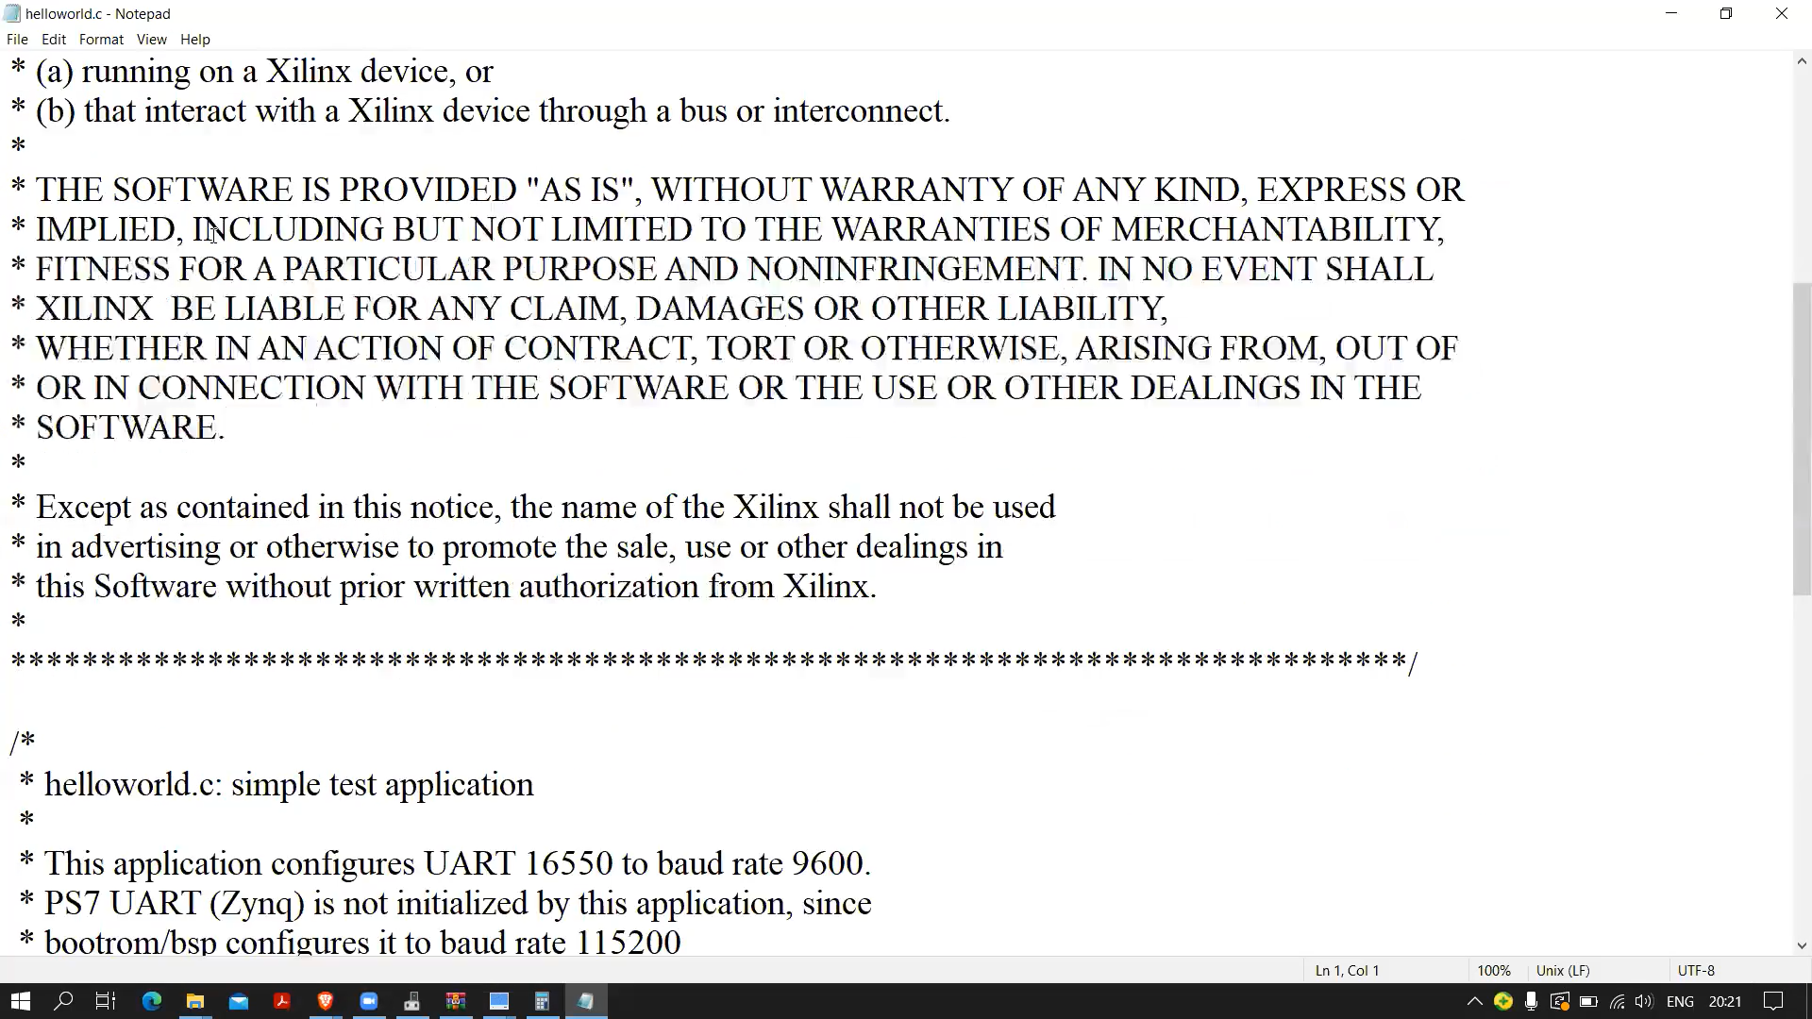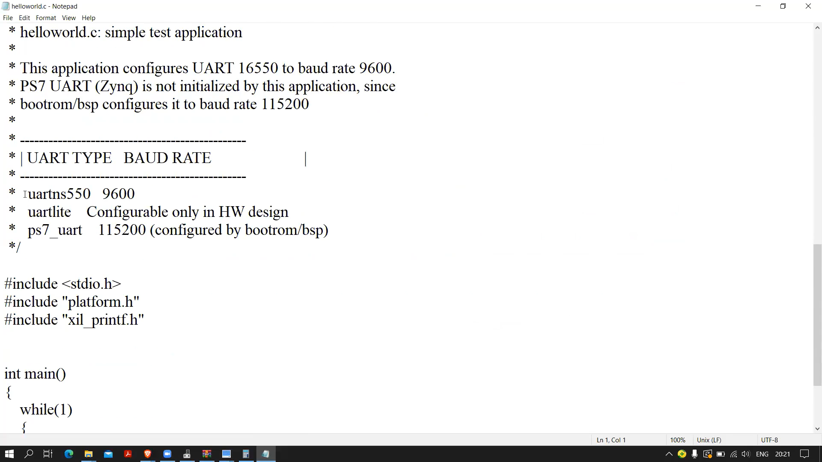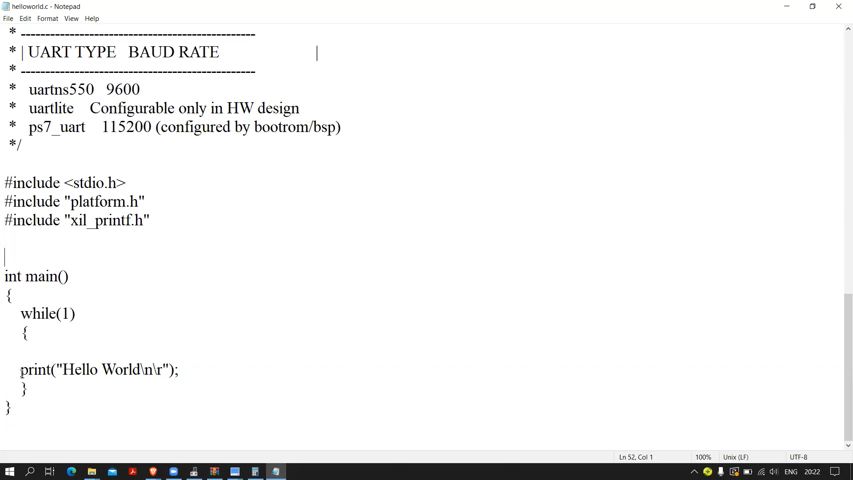

Things to know before proceeding,

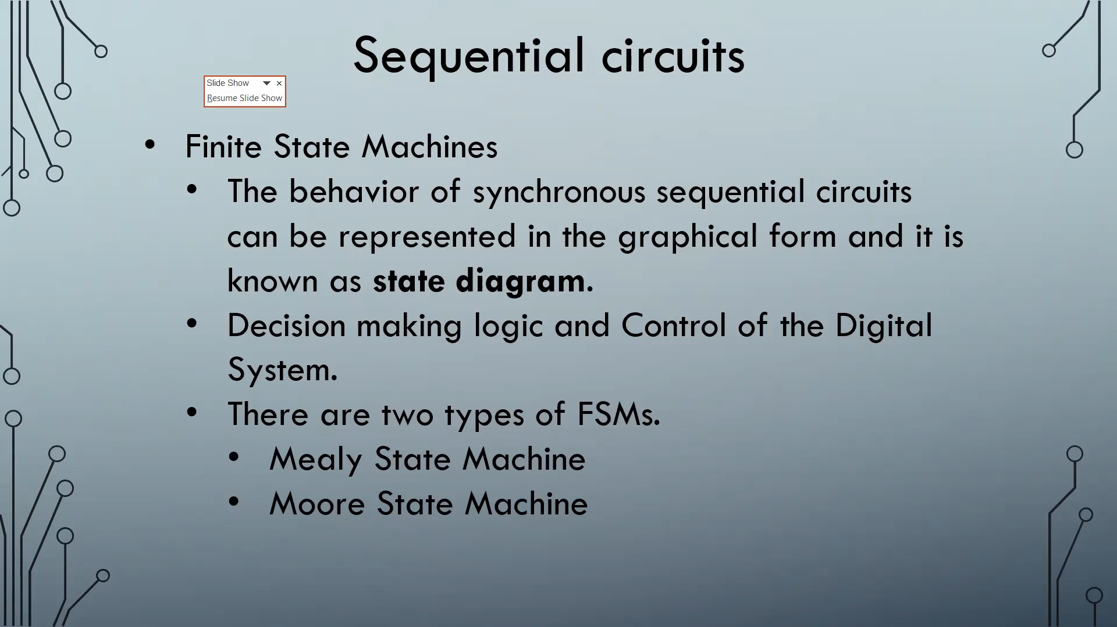Mealy state machines

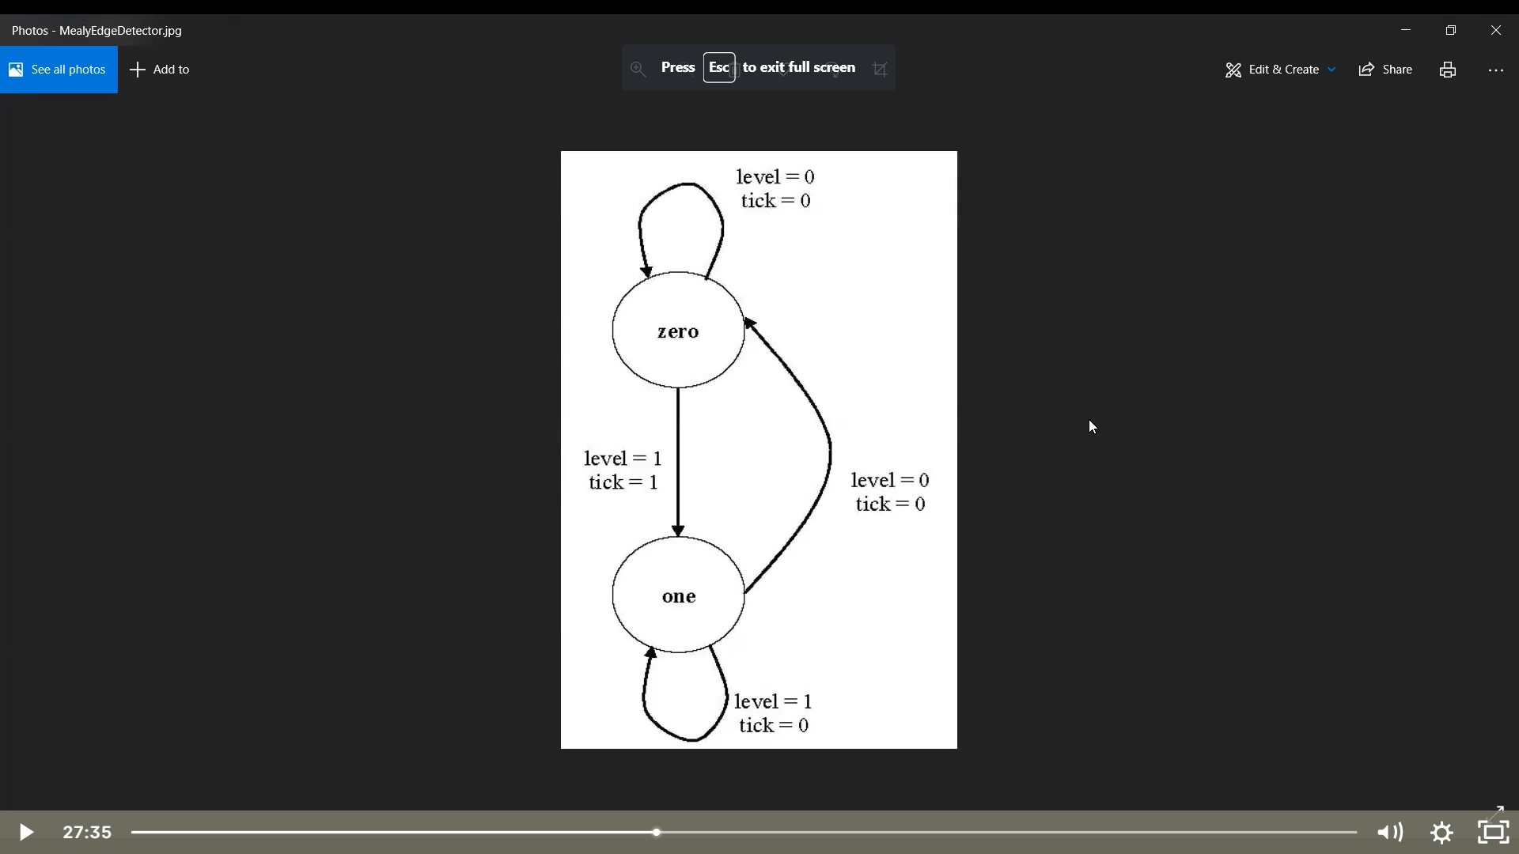

Moore state machines

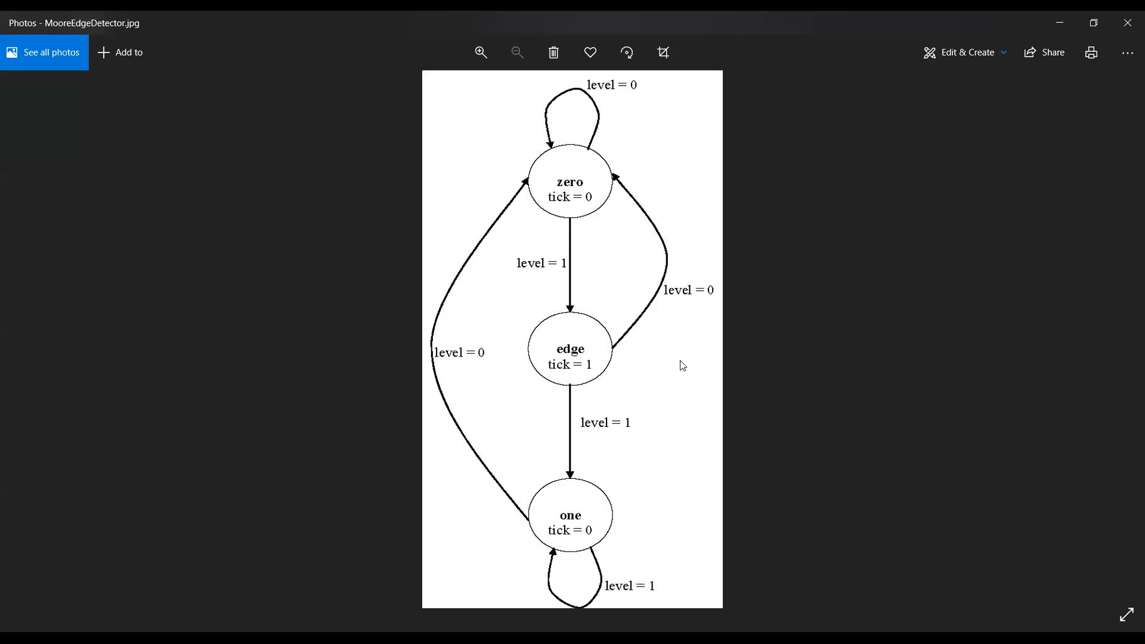

Step 3- Open notepad to write the Verilog code, a code to explain the basics of mealy and Moore state machine

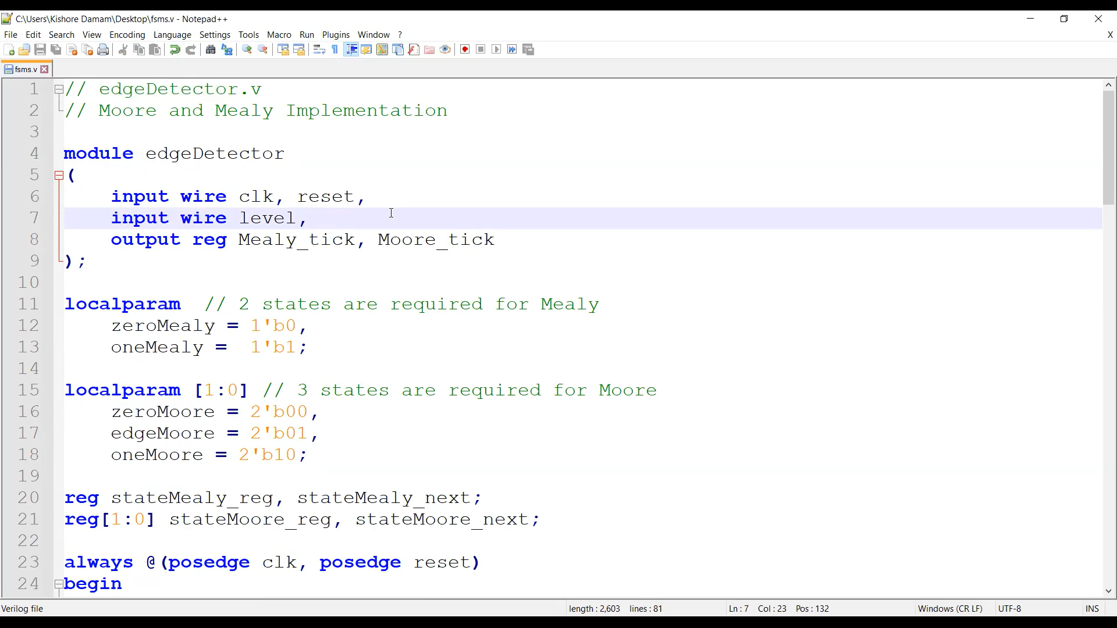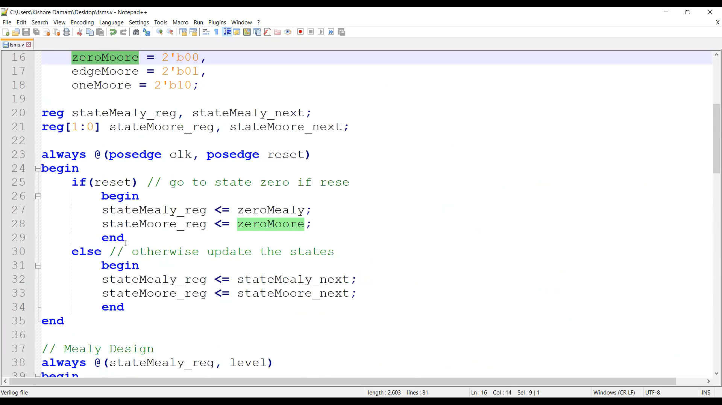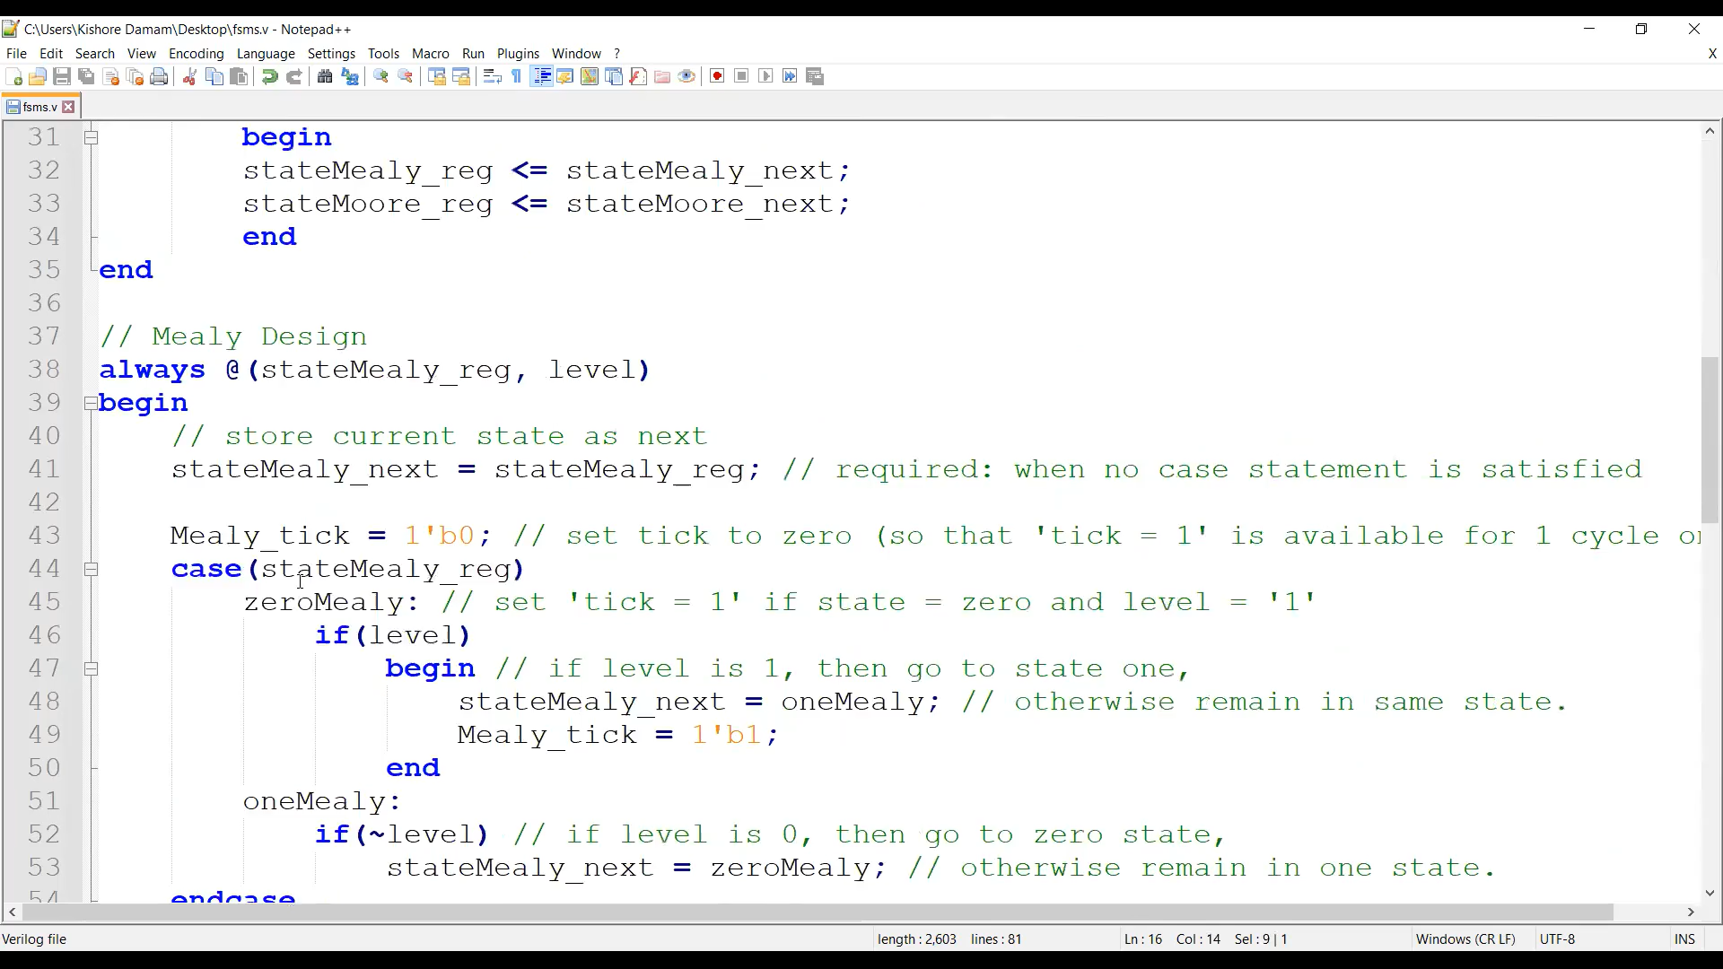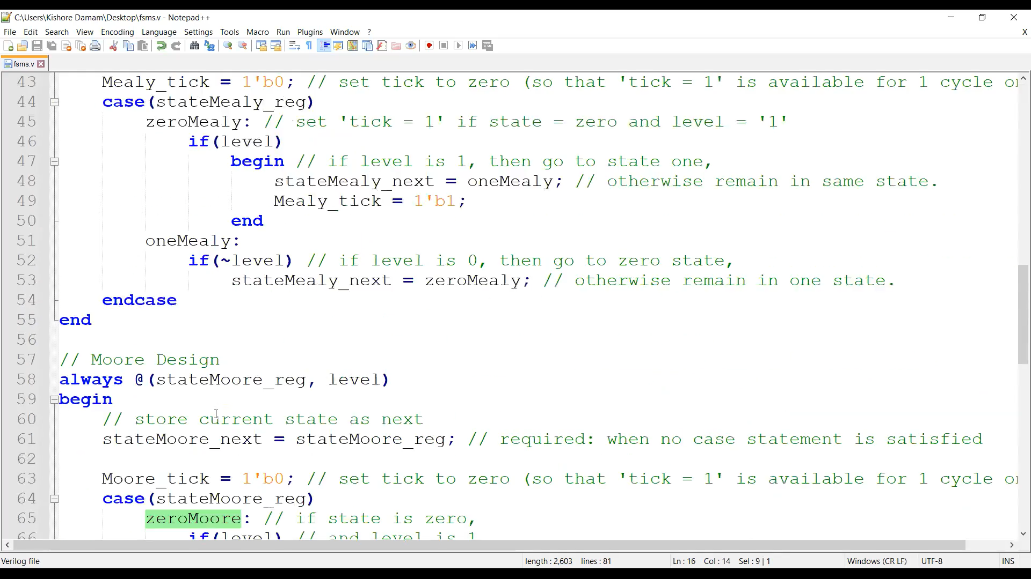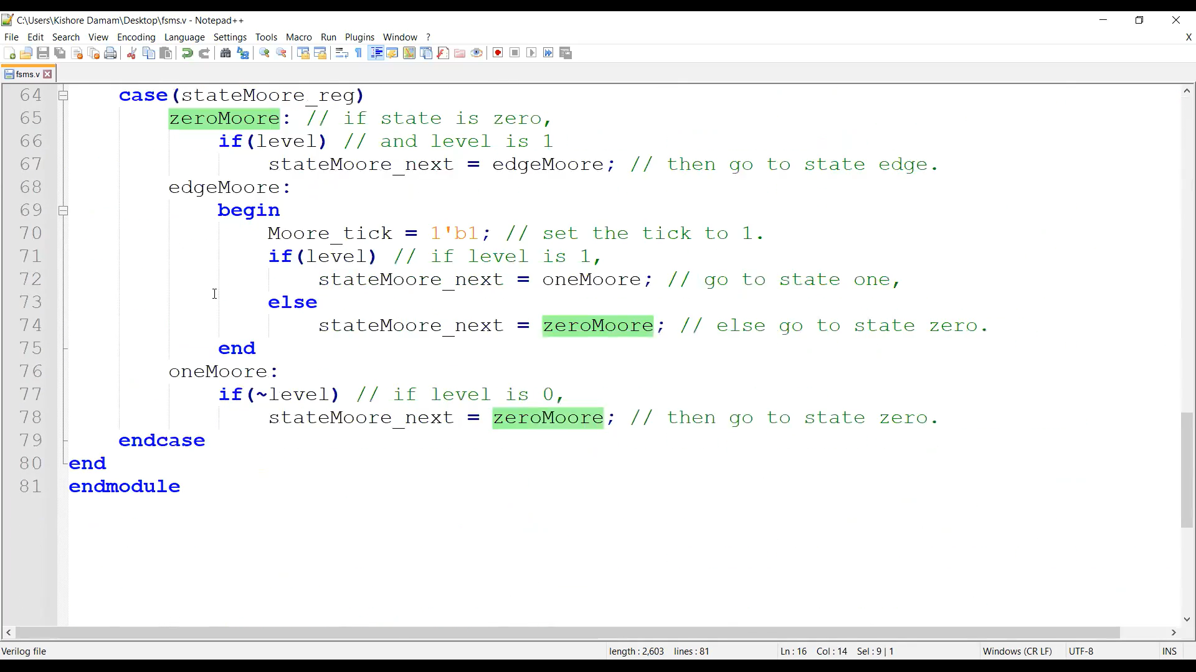Open notepad to write the verilog code, a code to explain the UART module

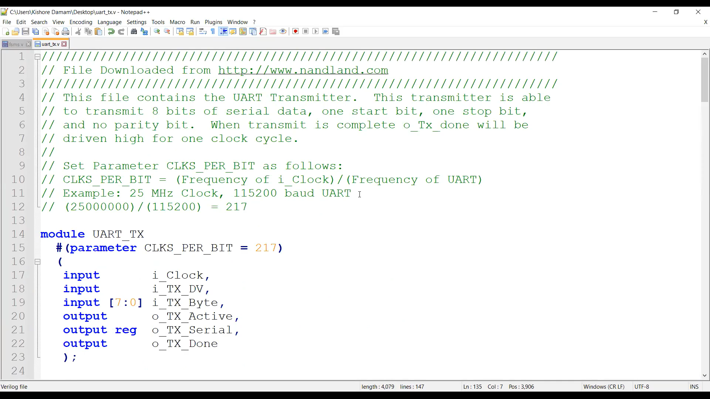

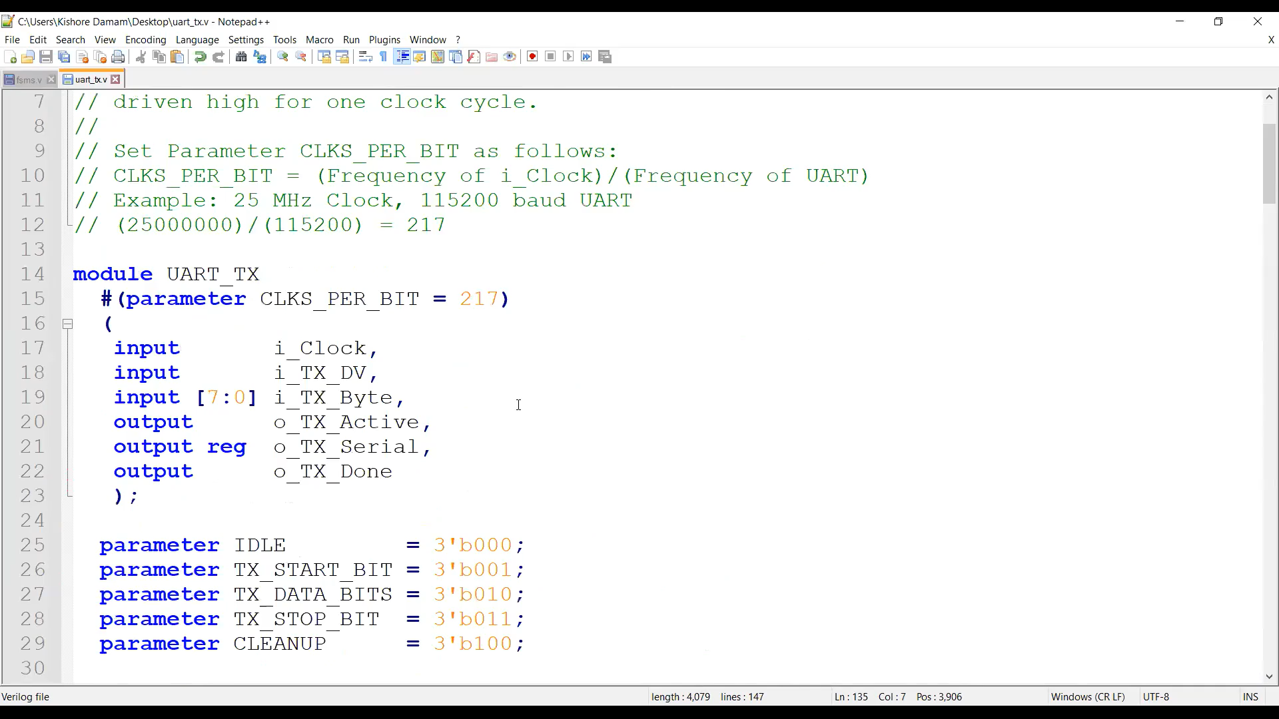

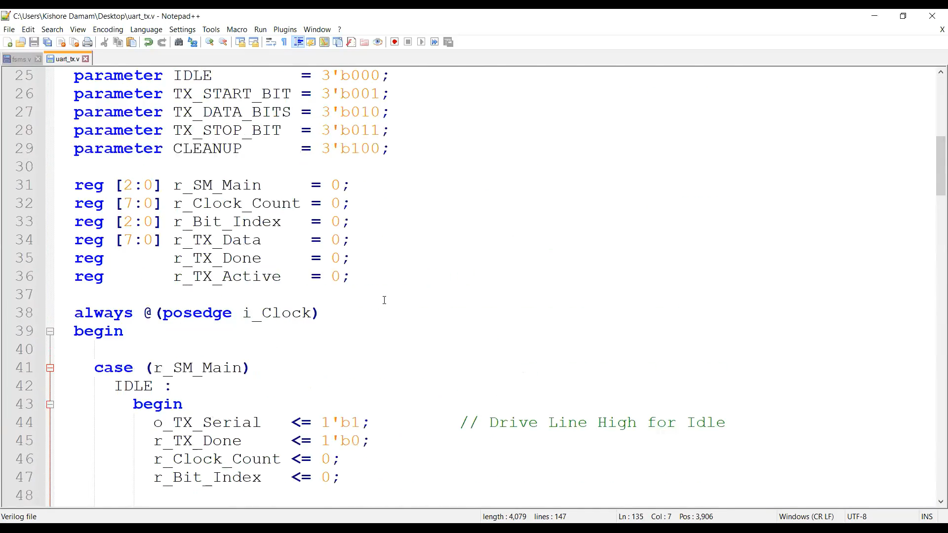

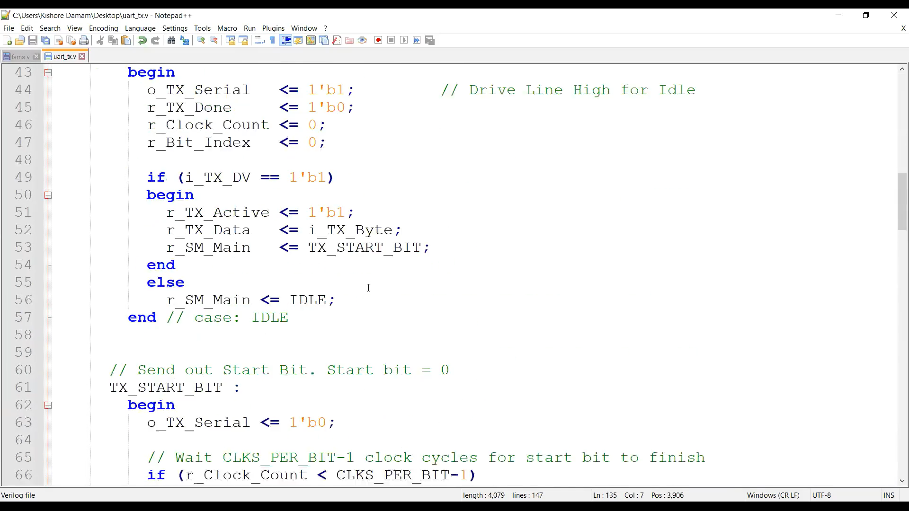

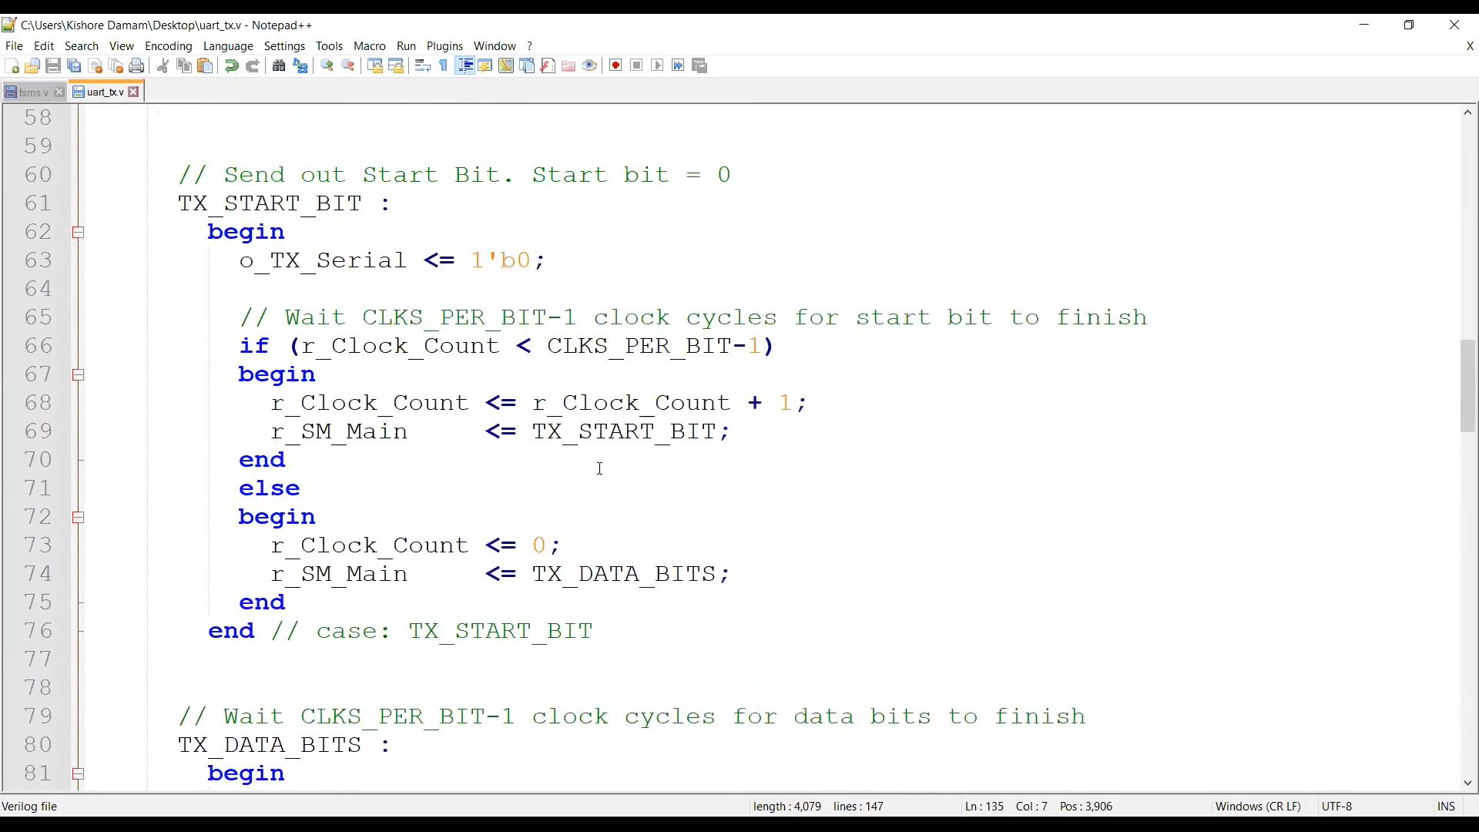

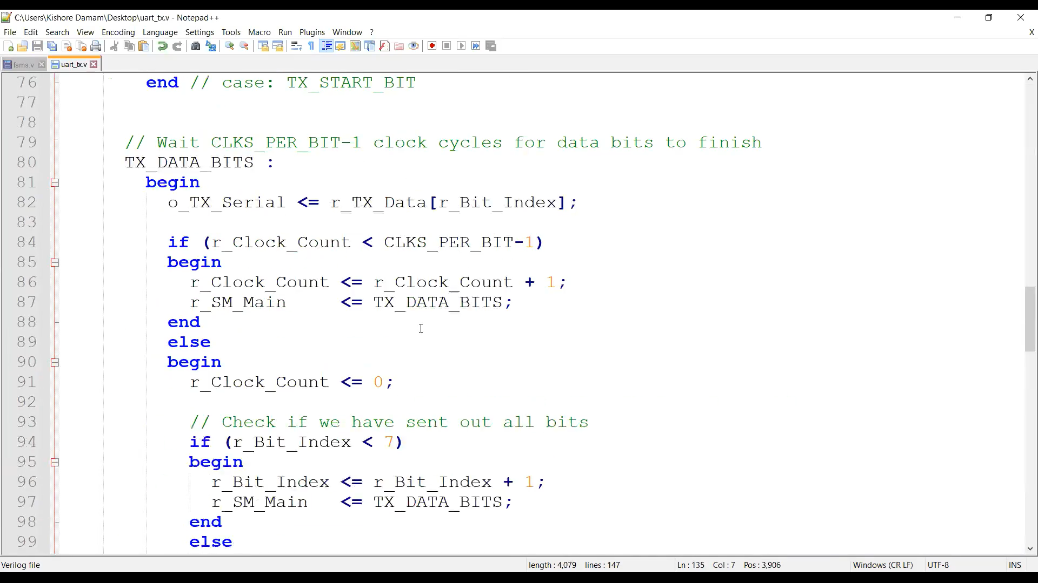

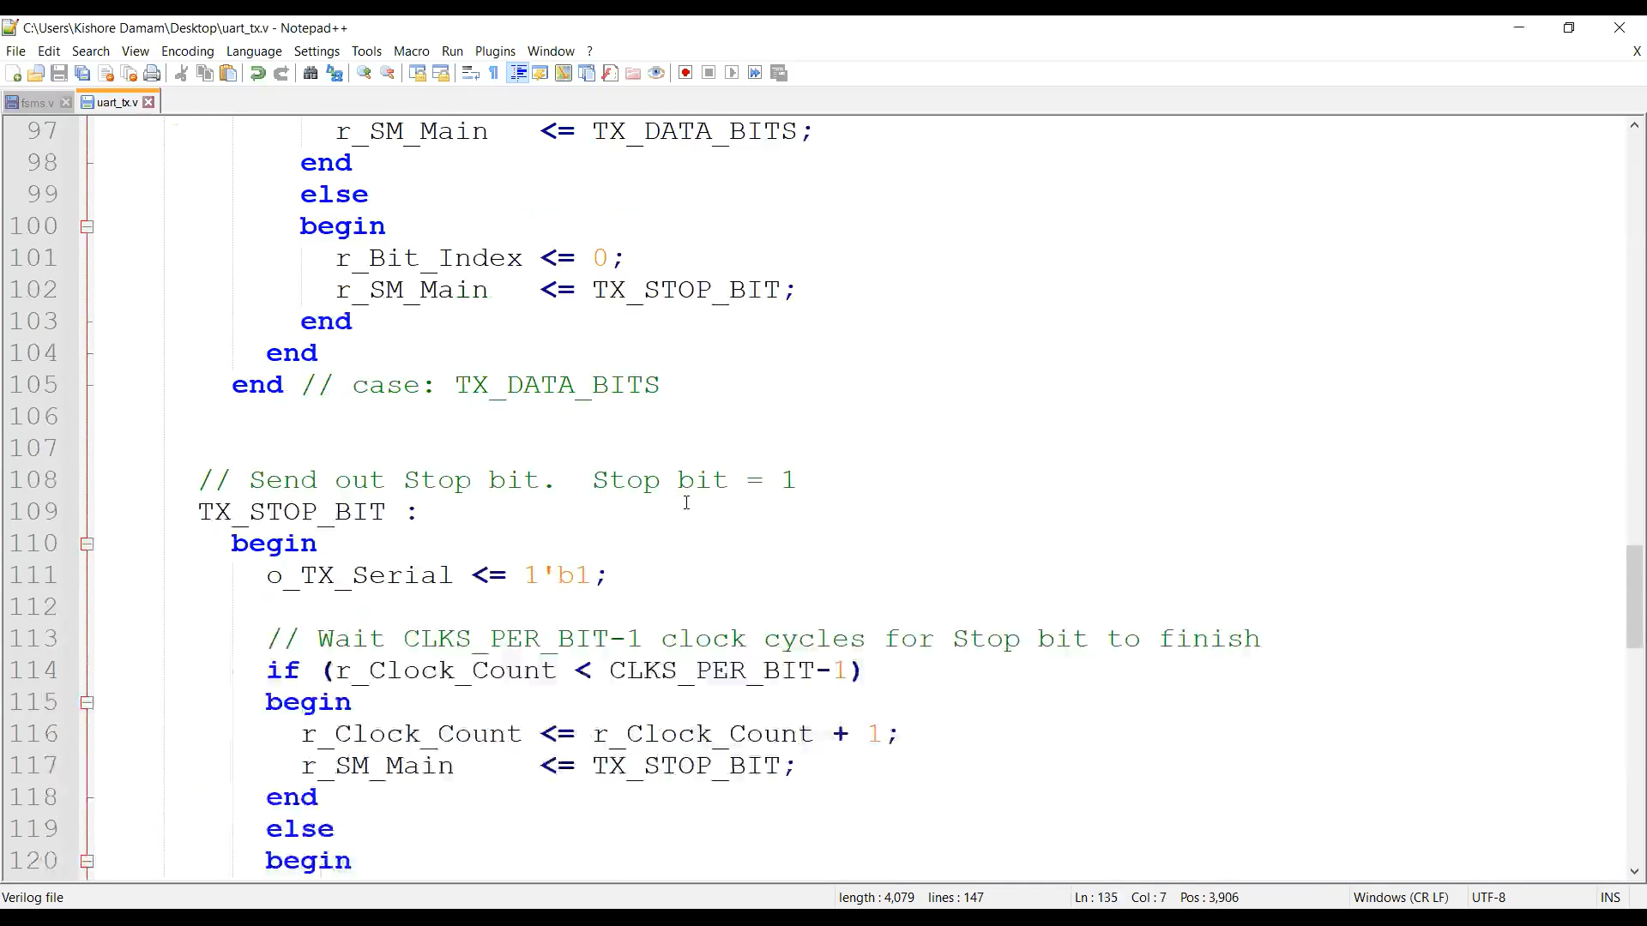

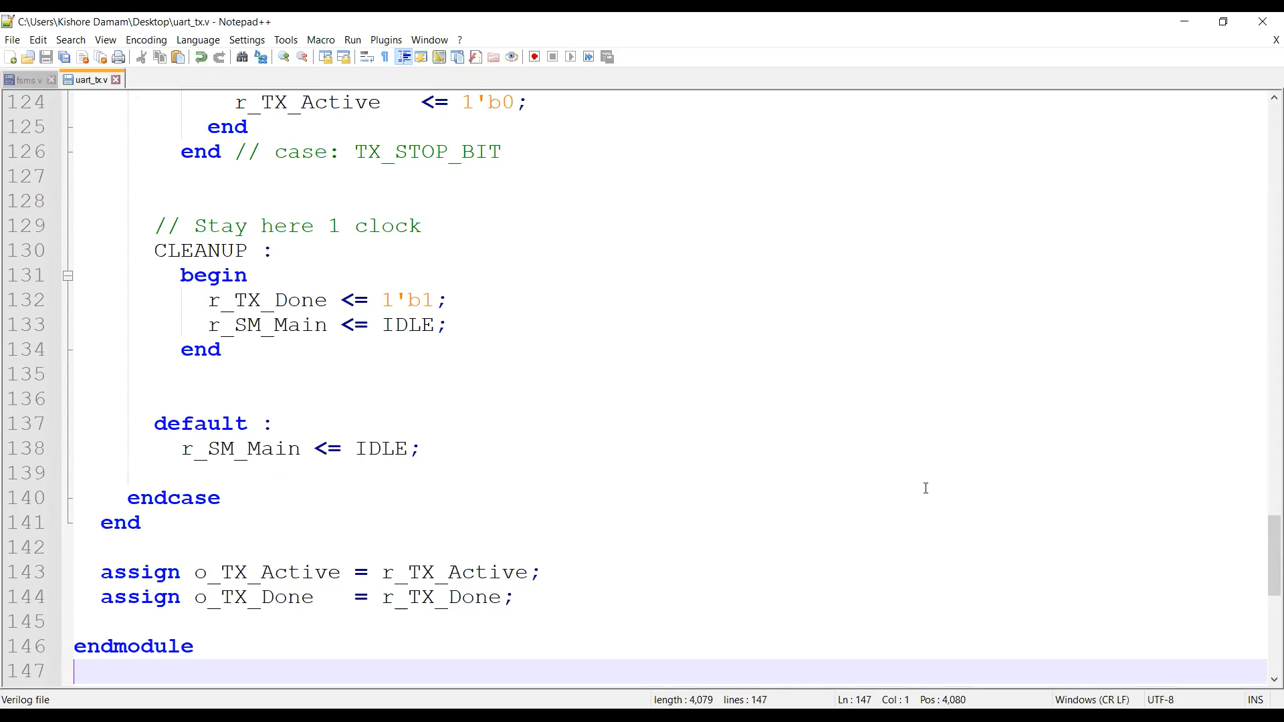Output

